Nebraska Game and Parks Commission's
Habitat Partners Section Regional Boundaries
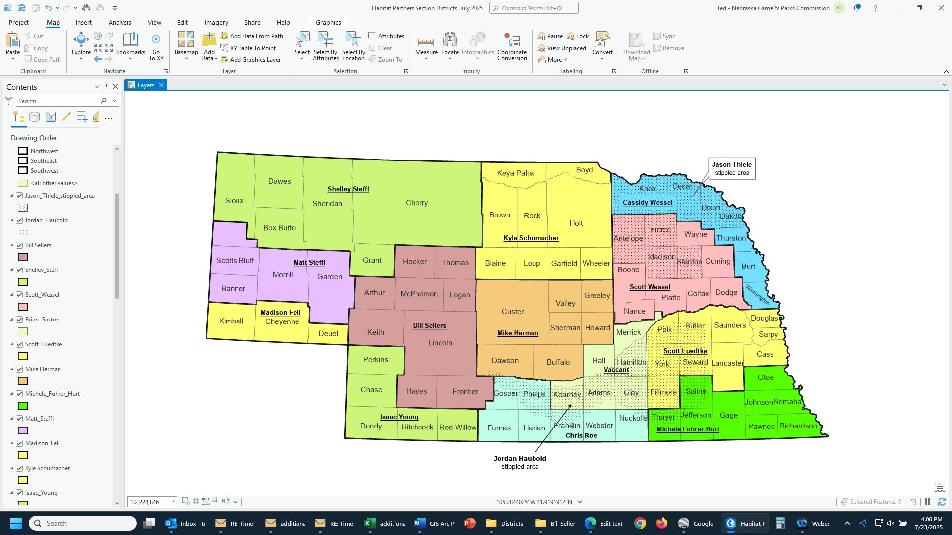
The regional boundaries displayed are for general guidance.
In the Northwest District, Matt Steffl will generally be handling wetland, lake, and stream projects in Shelley’s coverage area and Shelley will be covering the other projects.

In the Northeast District, Scott Wessel will generally be handling Grants, Partnerships, and WRE; Jason Thiele will generally be handling Open Fields and Waters, Berggren Pheasant Plan, and EQIP Wildlife Incentives Program; Kyle Schumacher will generally be handling Fire Coordinator issues, Great Plains Grassland Initiative, and Working Lands for Wildlife; and Cassidy Wessel will generally be handling wetland and stream projects, and be the Tribal Liaison.

Jordan Haubold is the Rainwater Basin Wetlands Habitat Specialist. She will assist with private land projects in the Rainwater Basin, however for initial projects please contact the biologist listed for the county the project is in.
In some cases, the boundary lines may vary due to the program being delivered, location of the project, workload, etc. July 23, 2025

Nebraska Game and Parks Commission’s Habitat Partners Section
District Contact Information
LAST NAME | FIRST NAME | DISTRICT | OFFICE PHONE | CELL PHONE | TITLE | ADDRESS | TOWN | ZIP CODE | E-MAIL
FELL | MADISON | NORTHWEST |  | 308-249-2055 | BIOLOGIST | 2244 JACKSON STREET | SIDNEY | 69162 | madison.fell@nebraska.gov
FUHRER-HURT | MICHELE | SOUTHEAST | 402-228-0269 | 402-433-5077 | BIOLOGIST | 964 CHALCEDONY DRIVE | BEATRICE | 68310 | michele.fuhrer-hurt@nebraska.gov
VACCANT |  | SOUTHCENTRAL | 308-865-5332 | 308-223-0700 | DISTRICT MANAGER | 1617 FIRST AVENUE | KEARNEY | 68847-6057
HAUBOLD | JORDAN | SOUTHCENTRAL | 308-382-8112 | 402-580-1807 | BIOLOGIST | 2550 NORTH DIERS AVE., SUITE G | GRAND ISLAND | 68803 | Jordan.Haubold@nebraska.gov
HERMAN | MIKE | SOUTHCENTRAL | 308-865-5308 | 308-440-8160 | BIOLOGIST | 1617 FIRST AVENUE | KEARNEY | 68847-6057 | michael.herman@nebraska.gov
LUEDTKE | SCOTT | SOUTHEAST | 402-471-5561 | 402-580-1167 | DISTRICT MANAGER | P.O. BOX 30370 | LINCOLN | 68503-0370 | scott.luedtke@nebraska.gov
ROE | CHRIS | SOUTHCENTRAL | 308-478-5238 | 308-920-0239 | BIOLOGIST | 72775 V. Road | WILCOX | 68982-3508 | chris.roe@nebraska.gov
SCHUMACHER | KYLE | NORTHEAST | 402-893-2559 | 402-929-0813 | BIOLOGIST | 86502 GROVE LAKE ROAD | ROYAL | 68773-0044 | kyle.schumacher@nebraska.gov
SELLERS | BILL | SOUTHWEST | 308-535-8025 | 308-414-2140 | DISTRICT MANAGER | 301 EAST STATE FARM ROAD | NORTH PLATTE | 69101-0430 | bill.sellers@nebraska.gov
STEFFL | MATT | NORTHWEST | 308-763-2940 | 308-760-4847 | DISTRICT MANAGER | 299 HUSKER ROAD, P.O. BOX 725 | ALLIANCE | 69301-0725 | matt.steffl@nebraska.gov
STEFFL | SHELLEY | NORTHWEST |  | 308-430-3977 | BIOLOGIST | 430 E. 2nd St. | CHADRON | 69337-2433 | shelley.steffl@nebraska.gov
THIELE | JASON | NORTHEAST | 402-370-3374 | 402-370-0010 | BIOLOGIST | 2201 NORTH 13TH STREET | NORFOLK | 68701-2267 | jason.thiele@nebraska.gov
WESSEL | SCOTT | NORTHEAST | 402-370-3374 | 402-841-8817 | DISTRICT MANAGER | 2201 NORTH 13TH STREET | NORFOLK | 68701-2267 | scott.wessel@nebraska.gov
WESSEL | CASSIDY | NORTHEAST | 402-370-3374 | 402-360-1957 | BIOLOGIST | 2201 NORTH 13TH STREET | NORFOLK | 68701-2267 | cassidy.wessel@nebraska.gov
YOUNG | ISAAC | SOUTHWEST | 308-394-5156 | 308-414-1953 | BIOLOGIST | 73122 338th Ave. | ENDERS | 69027-9302 | Isaac.young@nebraska.gov
WALKER | T. J. | STATEWIDE | 402-471-5439 | 308-530-7659 | ASSISTANT WILDLIFE DIVISION ADMINISTRATOR | P.O. BOX 30370 | LINCOLN | 68503-0370 | thomas.walker@nebraska.gov

.

