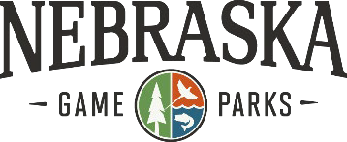

How to share your input during November:

1. Download and print the maps (below) and indicate your suggested changes. Be sure to include your name, phone number and email.
2. Feel free to create your own map of proposed changes and any additional info that you deem relevant.
3. Mail your proposed changes to:

Nebraska Game and Parks Commission c/o Zone Boundary Changes

2200 N. 33rd Street Lincoln, NE 68503

Criteria for zone changes:

* Nebraska is allowed to have no more than four duck zones.
* Zones or units must be contiguous.
* Boundaries must be readily identiﬁable. Roads are preferred.
* Only written comments will be accepted.
* Exceptions will be made for those without access to a printer.
* Comments regarding no change are as important as comments regarding a change.
* Make proposed changes as small as possible. Larger changes typically aﬀect

other hunters that may not agree with your change, resulting in no change.

* Need apparent majority of hunters in area for zone or unit boundary change. No apparent majority results in a no change to the boundary.

**Dark (Canada) Goose Unit Boundary Changes**

Please indicate on the map and describe below where you wish to propose a change in the dark (Canada) goose unit boundaries. If you are currently satisfied with the unit boundaries in the area you hunt, please indicate on map where you hunt and state in description below you do not want any changes.

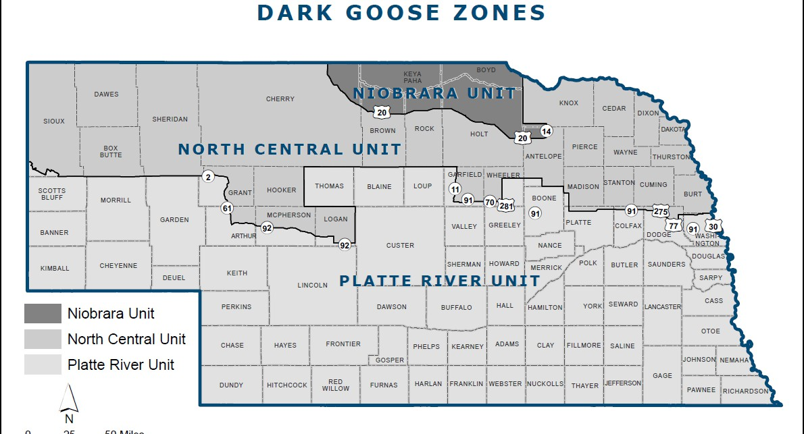

Write description of proposed unit boundary change here. Also include name, phone number and email address.

**Mail form to:** Nebraska Game and Parks Commission, c/o Zone Boundary Changes, 2200 N. 33rd St., Lincoln, NE 68503